
How to get help

Our receptionists are available on the telephone from 8am to 6.30pm, Monday to Friday, to arrange appointments and deal with any queries.
Alternatively, you can use our online service, askmyGP, which is accessible through the practice website: www.wales.nhs.uk/sites3/home.cfm?orgid=551 which offers patients a different way to contact their GP.
Opening Times
Both surgeries are open from 8.30am to 6.30pm, Monday to Friday. We are closed on weekends and public holidays.
Out of Hours
If you have an urgent problem which cannot wait until the surgery re-opens, the Out of Hours Service can be contacted by dialling 111 ☎. Remember, that this service is for problems that cannot wait until the surgery reopens.
For severe problems such as difficulty breathing, chest pains, severe bleeding or suspected broken bones, you should call 999.
COVID Symptoms
If you have any COVID symptoms, do not attend the surgery. Contact 111 for advice.

CWMAVON AND CYMMER HEALTH CENTRE NEWSLETTER: March 2022
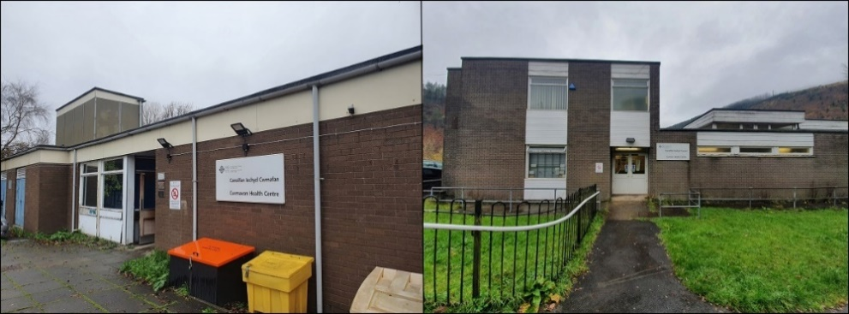
Hello - and welcome to your first newsletter from the Cwmavon and Cymmer Health Centre.
These newsletters are being delivered to homes in Cwmavon and Cymmer, to update you on what’s happening in these managed practice surgeries. (While we share Cwmavon Health Centre with Dr Penny’s practice, the newsletter is just about our services.)
You may be glad to hear that we’ve listened to your concerns and invested in extra staff in Cwmavon and Cymmer Health Centre. There are now six GPs across the two sites.
These GPs are employed directly by the Health Board to work in both sites carrying out face-to-face, virtual and telephone consultations. They are supported by our pharmacist, clinical physician associate, two nurses and two health care support workers, as well as our friendly office staff.
Cwmavon and Cymmer Health Centre is unusual because it’s managed directly by Swansea Bay University Health Board, rather than by independent general practitioners.
Cymmer Health Centre has been managed by the health board since 2005 and in 2017was merged with Cwmavon Health Centre to become one practice over two sites.
We’ll be keeping you up to date with future newsletters, so please look out for them!

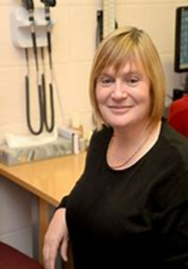
MEET THE TEAM
GPs:
Dr Claire Goodson Dr Jeremy Drury Dr Emma Davies
Dr Moshin Younas Dr Emily Dibdin Dr Heather Potter
Practice nurses: Eiriol Morris Michelle Guild
Healthcare Support Workers: Karen Bumford Nicola Sheppard
Introducing … Dr Heather Potter
“I have been a GP for 32 years. I retired as a clinical partner in Skewen Medical Centre in early 2021 and joined Cwmavon and Cymmer Managed Practice as a salaried GP in May 2021, working two days a week.
I have special interests in gynaecology, menopause, mental health and contraception, including implants and coil fitting.
I am married to my husband, who is a child phycologist, and we have three grown up children.
My hobbies are any type of fitness, including swimming, walking and going to the gym.”
Recent improvements to Cwmavon and Cymmer Health Centre

Access
You can access the practice via telephone or askmyGP, details of which can be found on the front page. We realise patients may face a lengthy wait calling the practice and understand how frustrating such delays can be. However we are currently receiving nearly 2,000 calls a week, so we would ask you to try to call outside of usual peak times (8am-10am and 2pm-4pm), if possible; or try askmyGP.

Telephone system
We have listened to your feedback and have introduced a new telephone system to improve performance and call handling. It has:
- Increased incoming calls to 100, to avoid callers hearing a continuous ring tone
- The option to proceed in Welsh or English has been added to the greeting, to reduce call waiting time.
- If the call remains unanswered, the caller will be told that the line is busy (previously the line would go silent).
- Callers are now in a queuing system, with updates on where they are in the queue and their approximate wait time.
- Our IT department investigates calls which are cut off and reported to the practice

askmyGP
- askmyGP now better supports patients and practices demands. New askmyGP hours are 6am to 12pm, Monday to Friday. (Lines are open until 6.30pm for urgent calls)
The patient engagement for Cymmer Health Centre has now ended. Thank you to everyone who fed back via response forms, telephone, emails and joining us on the zoom sessions.

